From getting shot at with a toy gun by Quinten Terrentino, to being in a studio with Lady Gaga, to chatting with Dustin Hoffman, these are just a couple of the wide ranging experiences that Mr. Wickenden has had throughout his careers, including dance and being on a late night show, prior to BISB.

Mr. David Wickenden is a teacher of Modern Foreign Languages who has been teaching at BISB for the past seven years. At BISB, he has been teaching both Spanish and French to students in both the primary school and high school.

Last summer, Mr. Wickenden did not think he would still be at BISB. When he went back to Europe, he thought it would be the end of his time here. However, he ended up coming back.

“I realized how much I missed BISB. I missed Boston,” he said. “Mr. Nicholas very kindly gave me a job back. So I'm very happy to be here.”

Upon his trip to Boston to return to the school, he had to navigate the significant challenges of travelling during COVID-19. He was forced to quarantine in Bermuda, forcing him to miss the first few weeks of the school year.

Mr. Wickenden brings immense passion and energy to each of his classes on a daily basis. He feels that this passion and energy in his teaching comes from his 20 years as a performer.

“I think this passion is just a reflection of my attitudes to life,” he said. “You can take the boy off the stage but you can't take the stage out of the boy.”

Mr. Wickenden emphasized how important his energetic and interactive nature is in teaching languages.

“Sometimes the subject matter in language learning, especially the nuts and bolts of the mechanics, isn’t always the most exciting,” he said. “You have to learn your vocabulary, you have to learn your grammar rules, you have to learn your verb tables. So I think anything you can do to make that a little bit more fun and interactive is a great thing.”

Mr. Wickenden started his career as an 18 year old out of high school. He moved to Paris from the UK, thinking he would just be there shortly for his gap year but he quickly fell in love with the city. He found freedom in Paris: being away from his family, having his own salary, his own apartment, and his own life. He ended up staying there for ten years.

In Paris, he became a dancer in a completely unexpected way.

“I got a job as a waiter at the Moulin Rouge. On my very first night there, the curtain dropped and the lights came up and there was this huge spectacle in front of me. And I was like, ‘oh my God, that's what I want to do.’ And I’ve always been about taking the bull by the horns so I decided to try dance.”

His favorite memory from dancing came from the very first moment of his dancing career.

“So I left as a waiter and came back as a dancer, which was such a triumphant feeling. And on my first night, all the waiters who I was mates with, lined up around the back of the auditorium in a huge row. They all just cheered my first entrance on stage. I nearly tripped up, but it was amazing.”

Mr. Wickenden went all over the world during his career as a dancer and described what that lifestyle was like.

“It's a Peter Pan lifestyle because you sign a contract for a year in somewhere like South Korea. And all you need to do is be at the airport on the right day and the right time. And then everything's taken care of, you get flown out, you get put in their apartment or house, and you go do your job. It is lots of fun.”

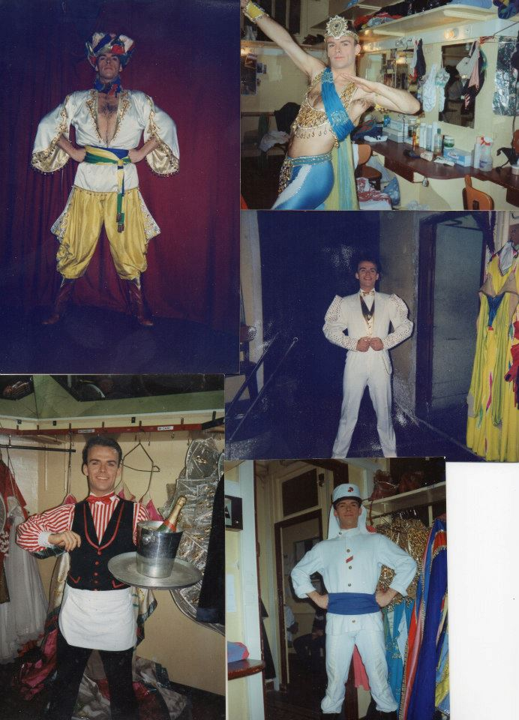

Mr. Wickenden had always promised himself that he would go back to school. This led him to retire from dancing and return to the UK where he did a degree in Spanish and French and then did a master’s degree in social and political thought at the University of London. It was during this time, when Mr. Wickenden formed a four part harmony group. They achieved a TV gig on the late night show, Friday Night with Jonathan Ross.

“We got offered the gig in early 2001,” he said. I took the call about it and I just said, yes, I didn't ask where, when, how much, I just grabbed that opportunity with both hands and ran with it. We didn't know in the beginning, whether we would be back the next week or whether the series would be recommissioned. We ended up doing 18 series. It started off as seven shows per series, but became up to 20 per series a year. So it became a full-time job and it was great.”

On the show, Mr. Wickenden got to meet many celebrities.

*Mr. Wickenden and his group with Daniel Radcliffe on the show.* 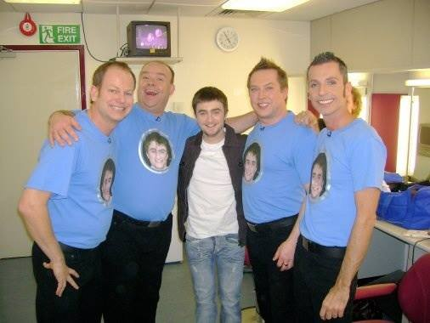

“Some of the guests on the show were heroes of mine, people who were just so incredibly talented when they came on,” Mr. Wickenden said. “We had Lady Gaga on a couple of times, quite early in her career. And I was in the studio with her while she was just jamming by herself on the piano. And I was like, ‘wow, this girl is really good.’ Some of the other celebrities who came included David Bowie, Stevie Wonder, Barbara Streisand, Daniel Radcliffe*,* and many other movie stars.

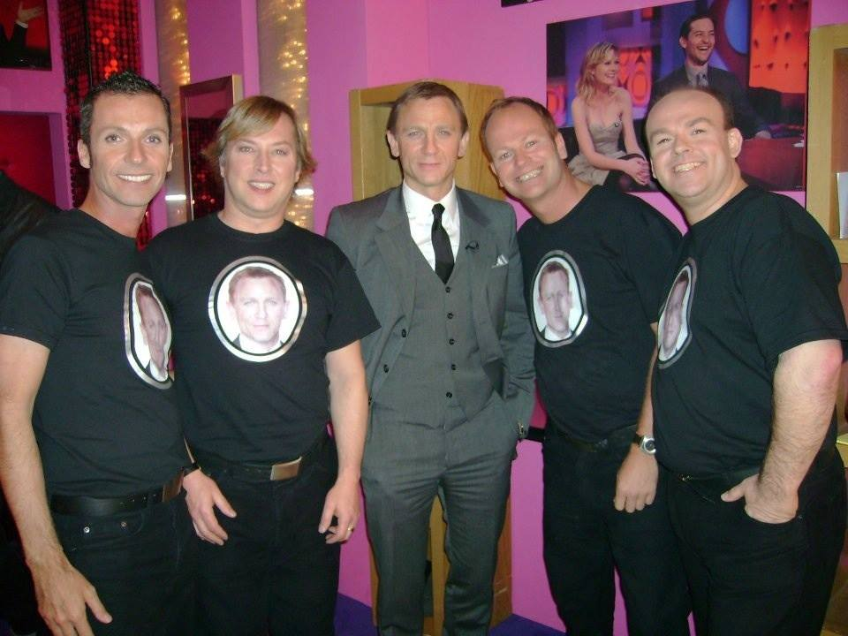

*Mr. Wickenden and his group with Daniel Craig on the show*

Wickenden and his colleagues in the harmony group would be friends with the makeup department where they got to meet many of these celebrities.

“Everyone comes through the makeup so we would always meet people there,” he said. “Some of the celebrities were just so gracious, for example, Dustin Hoffman came over to us and introduced himself, saying, ‘Hi, my name's Dustin.’ Glenn Close came to the green room to sit around and chat with us. So yeah, they were just very loving.”

Wickenden has many such beloved memories from the show. One of his favorite memories, though, involved Quinten Terrentino.

“Quinten Terrentino came on and the host, Jonathan, playfully criticized his use of music in his movies, saying that he could do better. So at the end of the show, Jonathan came over to us at the piano and said, ‘Yeah, he really doesn't know anything about good music’. Then we started singing and Quinten Terrentino came back on set with a toy gun saying, ‘What are you saying, that I know nothing about music? I’ve had it with you.’ And just opens fire. We all get shot and [pretend] to die. It was such great fun.”

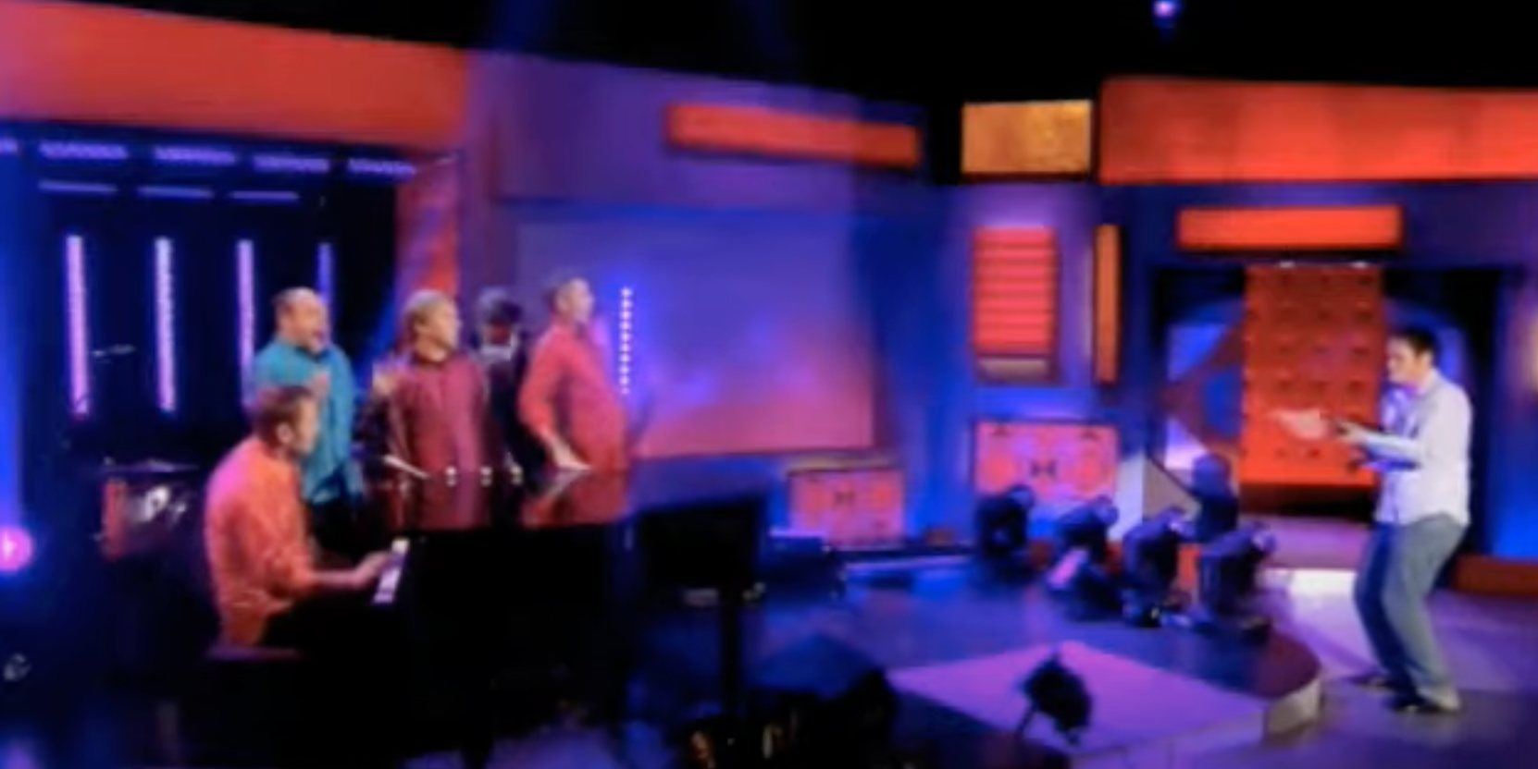

(Watch this with Quinten Terrentino scene here: [here](https://www.youtube.com/watch?v=cOUjNKc65es))

Mr. Wickenden and his group performed at the Edinburgh festival and on many TV shows along with the late night show.



*Mr. Wickenden and his group performing at the Edinburgh Festival*

Economic factors forced Wickenden to move on from his time as a performer.

“I realized that as the economy was in the doldrums at the time, it was getting increasingly difficult to make a living out of the performing arts. I had always thought I would become a teacher at some point so that is when I decided to go into teaching.”

Currently, while teaching at BISB, Mr. Wickenden is pursuing another graduate degree, this time in education. He never realized he would be able to do this.

“I've always loved being a learner. I've looked into continuing my studies but didn't really know that that would be an option here until my colleague Ms. Moustakim mentioned it to me. I looked into it and I thought, well, I'll throw my hat in the ring, not knowing what will happen. And I ended up getting accepted to do a part-time master's in education at Harvard. I've completed my first year now and I love it.”

Mr. Wickenden is optimistic about the future.

“I would love to continue my studies if possible in the future. I don't know how possible that is going to be, I'll be 57 when I graduate. So, we’ll see. At the moment I'm very happy here. I love my job. I love my life here in the city of Boston. I'm really looking forward to life getting back to normal and we'll see [what lies ahead].”